9) Grammar Checking for a Given String:
#include <stdio.h>
#include <ctype.h>
int main() {
char exp[] = "a + b * c"; // predefined input
int i, valid = 1;
for (i = 0; exp[i] != '\0'; i++) {
char c = exp[i];
if (!(isalnum(c) || c=='+' || c=='-' || c=='*' || c=='/' || c=='(' || c==')' || c==' ')) {
valid = 0;
break;
}
}
printf("Expression: %s\n", exp);
if (valid)
printf("Result: Valid according to grammar\n");
else
printf("Result: Invalid expression\n");
return 0;
}

OUTPUT:
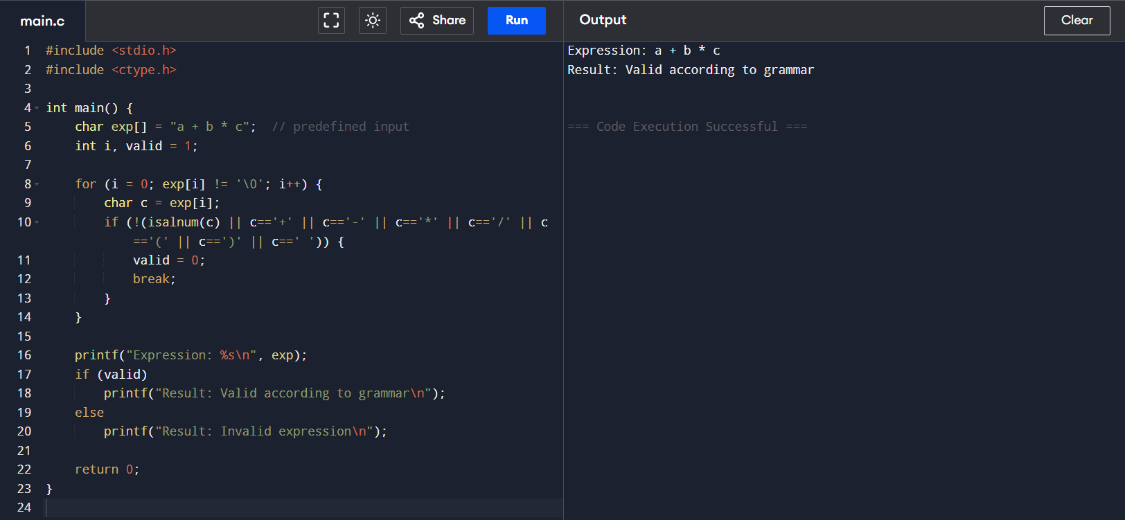

10) Recursive Descent Parser:
#include <stdio.h>
#include <ctype.h>
#include <stdlib.h>

const char *p = "a + b * ( c + d )"; // predefined expression

void skip() { while (*p == ' ') p++; }
void error() { printf("Invalid Expression\n"); exit(0); }
void match(char c) { skip(); if (*p == c) p++; else error(); }

void E(), Eprime(), T(), Tprime(), F();

void E() { T(); Eprime(); }
void Eprime() { skip(); if (*p == '+') { match('+'); T(); Eprime(); } }
void T() { F(); Tprime(); }
void Tprime() { skip(); if (*p == '*') { match('*'); F(); Tprime(); } }
void F() {
skip();
if (isalpha(*p)) { while (isalnum(*p)) p++; }
else if (*p == '(') { match('('); E(); match(')'); }
else error();
}

int main() {
printf("Expression: %s\n", p);
E(); skip();
if (*p == '\0') printf("Result: Expression is valid\n");
else printf("Result: Invalid Expression\n");
return 0;
}
OUTPUT:
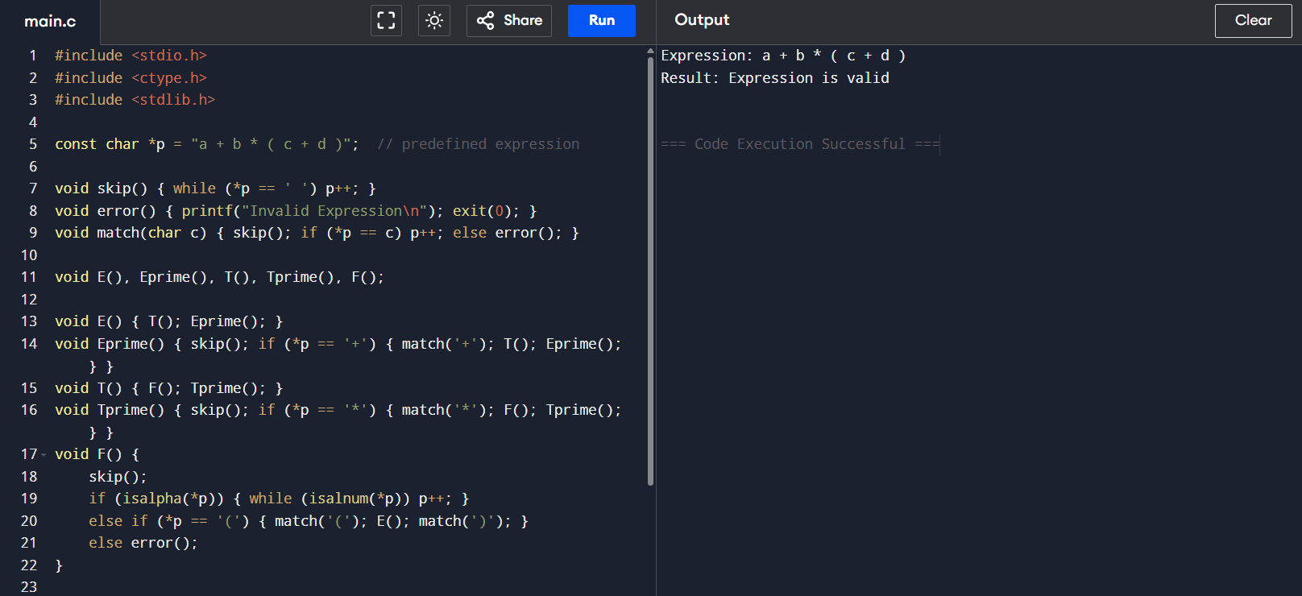
11) Operator Precedence Parsing (Infix → Postfix):
#include <stdio.h>
#include <ctype.h>
#include <string.h>

int prec(char c) {
if (c=='^') return 3;
if (c=='*' || c=='/') return 2;
if (c=='+' || c=='-') return 1;
return 0;
}

int main() {
char infix[] = "a+b*c-d"; // predefined expression
char stack[50], postfix[50];
int top=-1, k=0;

for (int i=0; infix[i]!='\0'; i++) {
char c = infix[i];
if (isalnum(c)) postfix[k++] = c;
else if (c=='(') stack[++top] = c;
else if (c==')') {
while (top!=-1 && stack[top]!='(')
postfix[k++] = stack[top--];
top--;
} else { // operator
while (top!=-1 && prec(stack[top]) >= prec(c))
postfix[k++] = stack[top--];
stack[++top] = c;
}
}
while (top!=-1) postfix[k++] = stack[top--];
postfix[k] = '\0';

printf("Infix: %s\nPostfix: %s\n", infix, postfix);
return 0;
}

OUTPUT:
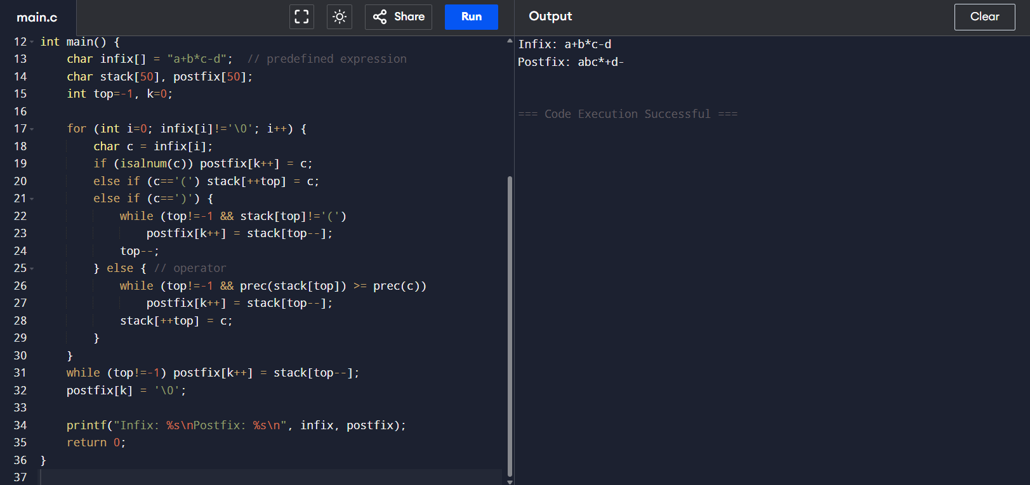

12) Three Address Code Generation:
#include <stdio.h>
#include <string.h>

int main() {
char exp[] = "a = b + c * d"; // predefined expression
printf("Expression: %s\n", exp);

printf("\nThree Address Code:\n");
printf("t1 = c * d\n");
printf("t2 = b + t1\n");
printf("a = t2\n");

printf("\nResult: Successfully generated 3-address code.\n");
return 0;
}

OUTPUT:
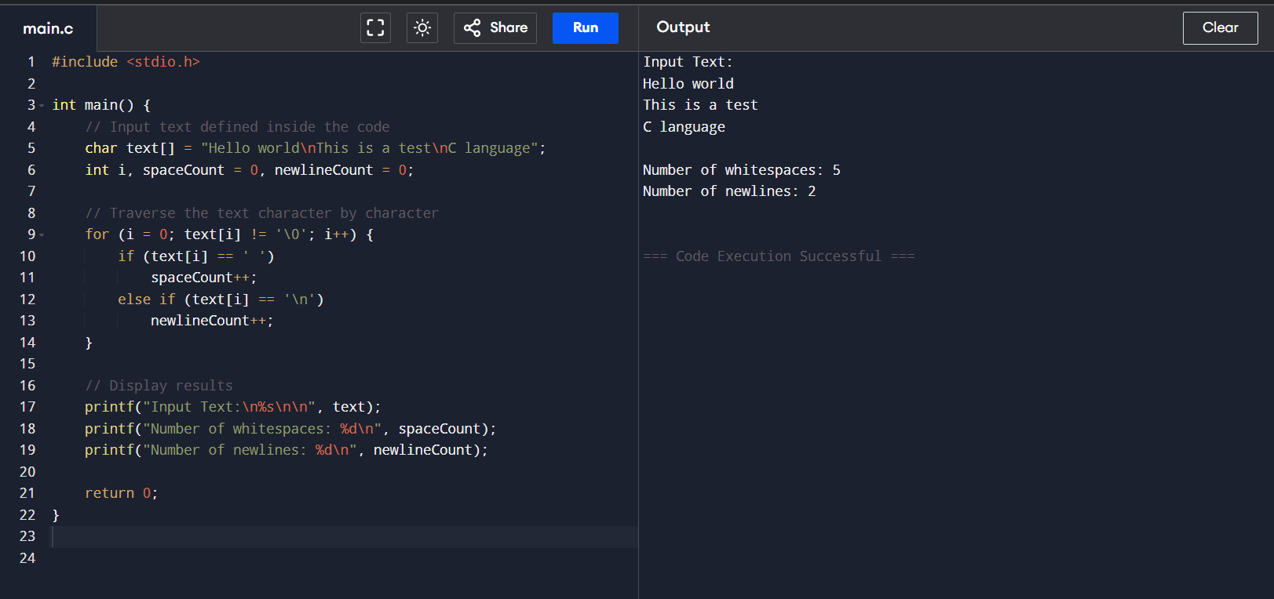
13)
#include <stdio.h>
#include <ctype.h>
#include <string.h>
// List of few C keywords to check
char keywords[][10] = {
"int", "float", "char", "if", "else", "while", "for", "do", "return", "void"};
// Function to check if a string is a keyword
int isKeyword(char str[]) {
for (int i = 0; i < 10; i++) {
if (strcmp(str, keywords[i]) == 0)
return 1; }
return 0;}
// Main function
int main() {
// Input defined inside the code
char id[] = "_abc12";
int i, valid = 1;

printf("Given identifier: %s\n", id);

// Check first character
if (!(isalpha(id[0]) || id[0] == '_')) {
valid = 0;
} else {
// Check rest of the characters
for (i = 1; id[i] != '\0'; i++) {
if (!(isalnum(id[i]) || id[i] == '_')) {
valid = 0;
break; }
}
}
// Final check
if (valid) {
if (isKeyword(id))
printf("→ Invalid identifier (it is a keyword)\n");
else
printf("→ It is a valid identifier.\n");
} else {
printf("→ Invalid identifier.\n"); }
return 0;
}

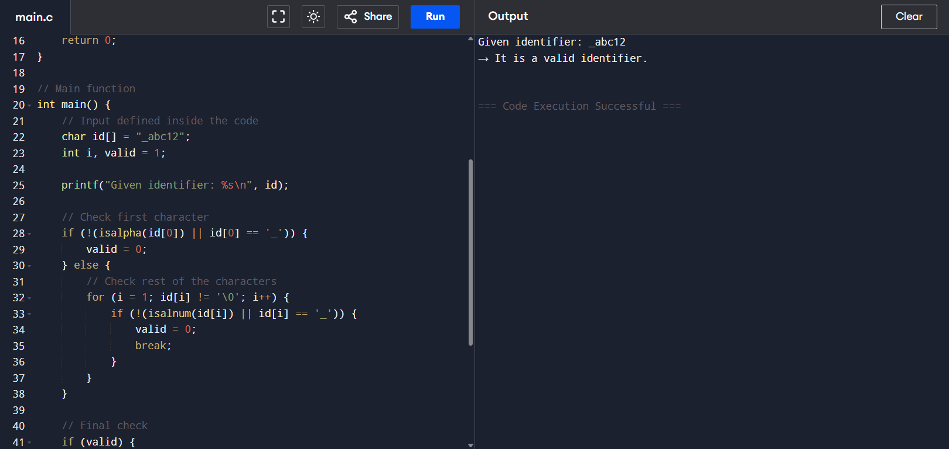
OUTPUT:

6) Implementation of a C Program to Eliminate Left Recursion:

#include <stdio.h>
#include <string.h>

int main() {
char input[] = "A->Aa|b", lhs, alpha[10][10], beta[10][10];
int i=3,j=0,k=0,l;

lhs = input[0];

while (input[i]!='\0') {
if (input[i]=='|') { i++; continue; }
if (input[i]==lhs) {
i++; l=0;
while (input[i]!='|' && input[i]!='\0') alpha[j][l++]=input[i++];
alpha[j][l]='\0'; j++;
} else {
l=0;
while (input[i]!='|' && input[i]!='\0') beta[k][l++]=input[i++];
beta[k][l]='\0'; k++;
}
}

printf("Given Production: %s\nAfter eliminating left recursion:\n", input);

printf("%c->", lhs);
for (i=0;i<k;i++){ printf("%s%c'",beta[i],lhs); if(i!=k-1) printf("|"); }

printf("\n%c'->", lhs);
for(i=0;i<j;i++) printf("%s%c'|",alpha[i],lhs);
printf("ε\n");

return 0;
}

OUTPUT:

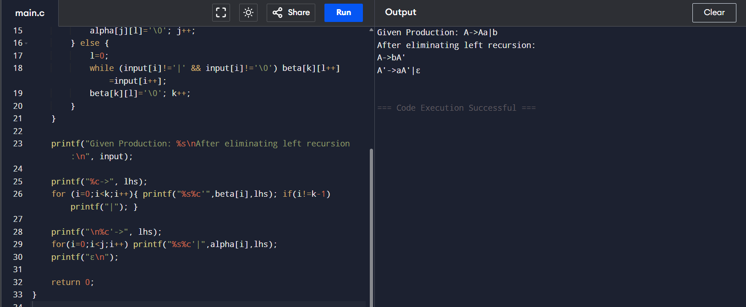

7) Lexical Analyzer to Eliminate Left Factoring:

#include <stdio.h>
#include <string.h>

int main() {
char input[] = "A->ab|ac|ad";
char lhs = input[0];
char rhs[10][10];
int i=3, j=0, k=0, l=0;

// Separate RHS by '|'
while (input[i]!='\0') {
if (input[i]=='|') { rhs[j][l]='\0'; j++; l=0; i++; continue; }
rhs[j][l++] = input[i++];
}
rhs[j][l]='\0'; j++; // total productions = j

// Find common prefix
char prefix[10];
int p = 0;
while(1) {
char c = rhs[0][p];
int same = 1;
for(int x=1;x<j;x++)
if(rhs[x][p]!=c) { same=0; break; }
if(!same || c=='\0') break;
prefix[p] = c; p++;
}
prefix[p]='\0';

// Print result
printf("Given Production: %s\nAfter left factoring:\n", input);
printf("%c->%sA'\n", lhs, prefix);
printf("A'->");
for(i=0;i<j;i++) printf("%s%s", rhs[i]+p, (i!=j-1)?"|":"");
printf("\n");

return 0;
}

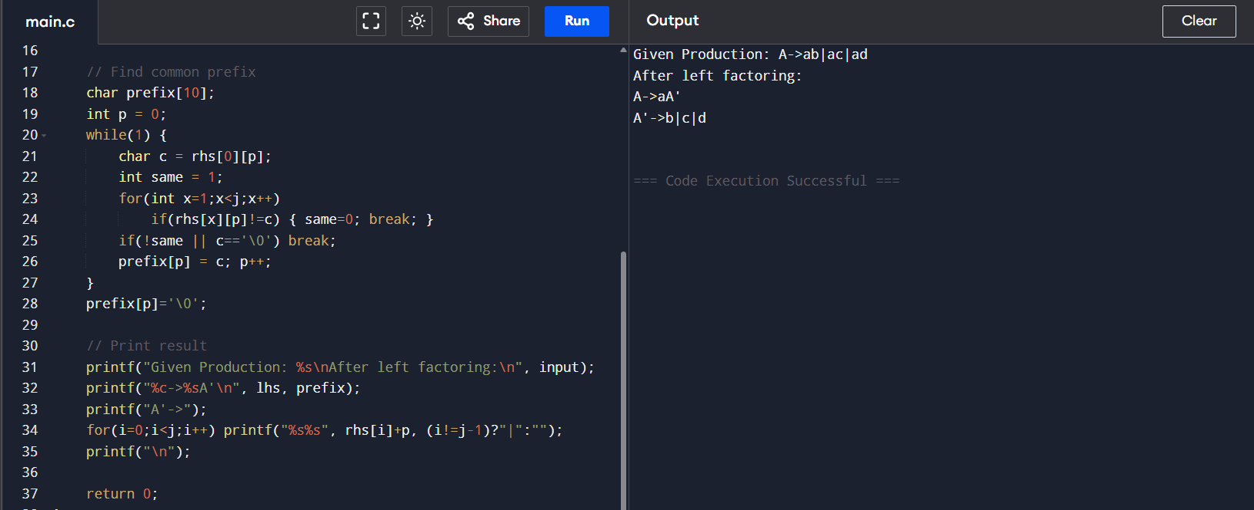
OUTPUT:

8) Implementation of Symbol Table Operations in C:

#include <stdio.h>
#include <string.h>

#define MAX 10

int main() {
char symbolTable[MAX][20]; // Symbol table array
int n = 4; // Number of identifiers
int i;

// Predefined identifiers
strcpy(symbolTable[0], "int");
strcpy(symbolTable[1], "sum");
strcpy(symbolTable[2], "total");
strcpy(symbolTable[3], "count");

printf("Inserted Identifiers:\n");
for(i=0;i<n;i++)
printf("%s\n", symbolTable[i]);

// Search examples
char search1[] = "sum";
char search2[] = "average";
int found = 0;

for(i=0;i<n;i++)
if(strcmp(symbolTable[i], search1)==0) { found=1; break; }
printf("\nSearch for '%s': %s\n", search1, found?"Found":"Not Found");

found = 0;
for(i=0;i<n;i++)
if(strcmp(symbolTable[i], search2)==0) { found=1; break; }
printf("Search for '%s': %s\n", search2, found?"Found":"Not Found");

return 0;
}

OUTPUT:

